**DAY 5: TESTING, ERROR HANDLING, AND BACKEND INTEGRATION, REFINEMENT:**

**CSV TEST REPORT:**

|  |  |  |  |  |  |  |  |  |  |  |
| --- | --- | --- | --- | --- | --- | --- | --- | --- | --- | --- |
| **Test Case ID** | **Test Case Description** | **Test Steps** | **Expected Result** | **Actual Result** | **Status** | **Severity Level** | |  | | --- | |  | | **Remarks** | |  | |
| TC001 | Validate product listing page | Open product page > Verify products | Product displayed properly aligned and correctly. | Product displayed properly aligned and correctly. | Passed | No Issues | No issues found products displayed correctly. |
| TC002 | Test API error handling | Disconnect API > Refresh page | Show fallback UI with error message | Error message shown | Passed | No Issues | |  | | --- | |  | | Handled gracefully | |  | |
| TC003 | Check cart functionality | Add product to cart > Verify cart contents | Cart updates with added product | Cart updates as expected | Passed | No Issues | |  | | --- | |  | | Cart  Works as expected | |  | |
| TC004 | Ensure responsiveness on mobile | Resize browser window > Check layout | Layout adjusts properly to screen size | Responsive layout working as intended on mobile and large computer screens. | Passed | No Issues | Test successful  Fully responsive. |

**STEP # 04: PERFORMANCE OPTIMIZATION (LightHouse):**

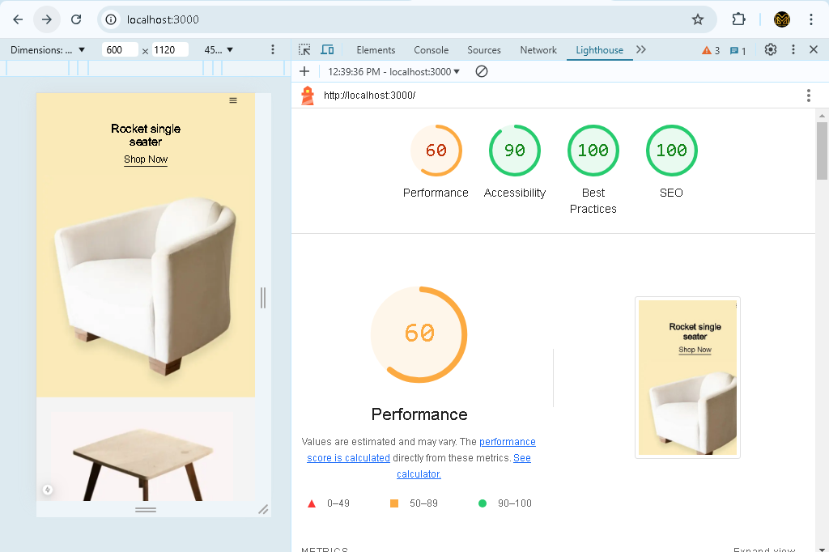

**STEP # 05: DEVELOPER RESOURCES:**

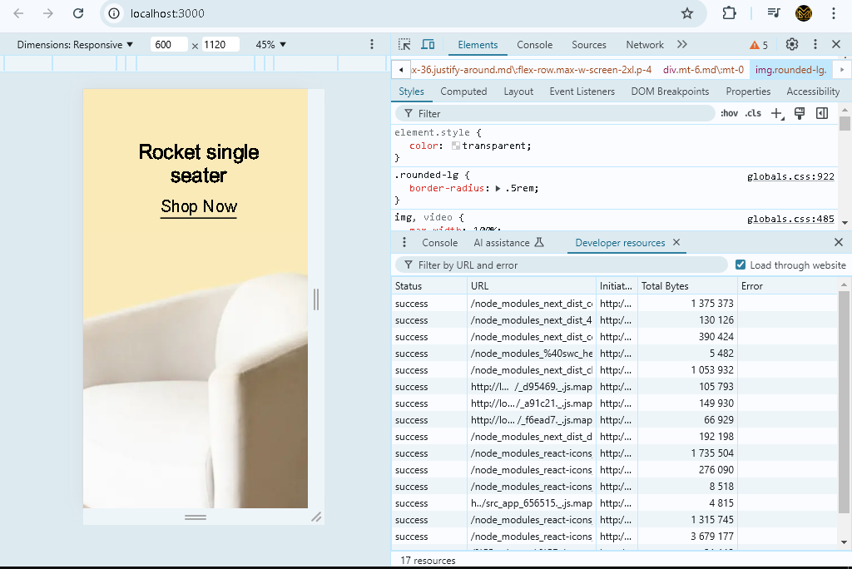

**PERFORMANCE MONITOR:**



**ISSUES:**

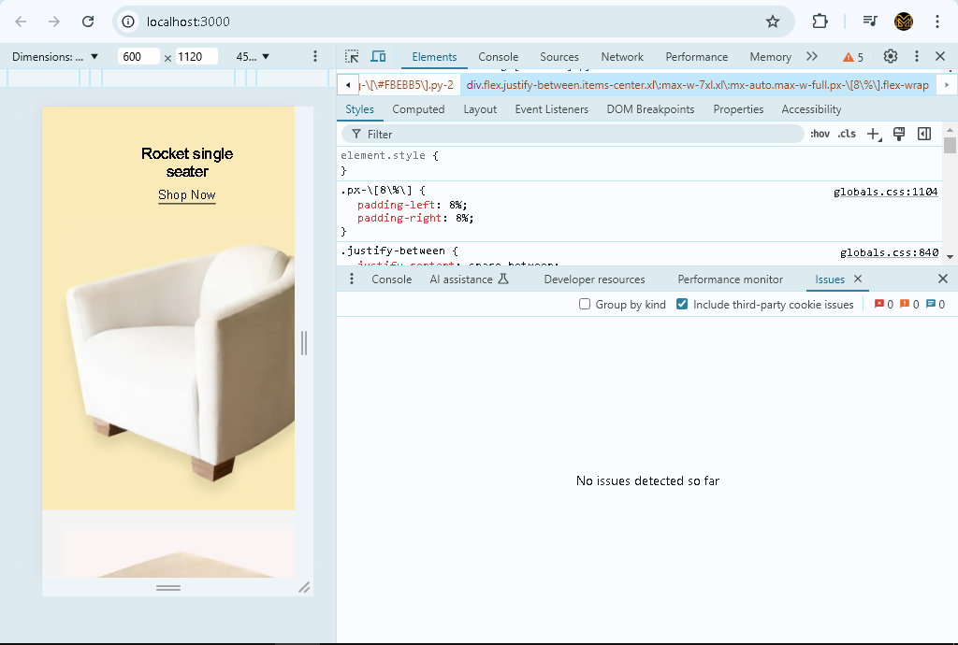

**SECURITY OVERVIEW:**

